**Develop Maps for Parliamentary and Assembly Constituencies using Web GIS**

M.Sc. Agriculture Analytics

**Submitted by:**

Manisha Shetty (202319028)



Dhirubhai Ambani Institute of Information and Communication Technology (**DA-IICT**)

**CONTENTS**

1. INTRODUCTION 3

1.1 Background 3

1.2 Objective 3

1.3 Scope 3

1.4 Parliamentary Constituency (PC) 4

1.5 Assembly Constituency (AC) 4

2. Dataset 5

2.1 PC Shapefile 5

2.2 AC Shapefile 5

3. Work Flow Chart 6

4. Data Pre-Processing 7

5. Development Process 8

6. RESULT 12

6.1 Layer Selection & Filtering 12

6.2 Legend Display 15

6.3 On click get info 16

6.4 Conclusion 17

REFRENCES 18

1. INTRODUCTION

## 1.1 Background

The delineation and mapping of parliamentary and assembly constituencies are fundamental to the democratic process. Accurate and accessible maps are essential for voters, political candidates, and electoral officials. Traditionally, these maps have been created and maintained using paper-based systems or basic digital tools, which often lack the interactivity and up-to-date information required in modern contexts. The advent of Web Geographic Information Systems (Web GIS) offers a powerful solution to these limitations by providing dynamic, interactive, and easily updatable maps accessible from any device with an internet connection.

## Objective

This project aims to develop detailed and interactive maps of parliamentary and assembly constituencies using Web GIS technology. By leveraging Web GIS, the project seeks to enhance the accessibility, accuracy, and usability of constituency maps, thereby supporting more informed decision-making processes and promoting greater electoral transparency and engagement.

## Scope

The scope of this project includes the development of a Web GIS application that will display constituency maps with detailed geographical and demographic information. The project will focus on a selected set of constituencies as a case study, demonstrating the application's capabilities and potential benefits. Key features of the application will include interactive map navigation, search functionality, and the integration of various data layers to provide a comprehensive view of each constituency.

In addition to the technical implementation, this project will also address the challenges associated with data collection and processing, such as ensuring data accuracy and managing large datasets. The report will cover the entire development process, from data acquisition to the deployment of the Web GIS application, providing insights into the methodologies and tools used.

The ultimate goal is to create a versatile and scalable solution that can be expanded to cover all constituencies, providing a valuable resource for electoral authorities, political analysts, and the general public.

## 1.4 Parliamentary Constituency (PC)

The [Lok Sabha](https://en.wikipedia.org/wiki/Lok_Sabha), the Lower House of the [Parliament of India](https://en.wikipedia.org/wiki/Parliament_of_India), is made up of [Members of Parliament](https://en.wikipedia.org/wiki/Member_of_Parliament,_Lok_Sabha) ([MPs](https://en.wikipedia.org/wiki/Member_of_Parliament_(India))). Each member of parliament represents a single geographic constituency. There are currently 543 constituencies while maximum seats will fill up to 550 (after article 331, 2 seats were reserved for Anglo Indian but by the 104th Constitution Amendment article 331 was null by parliament before this amendment maximum number of seats was 552).

The maximum size of the Lok Sabha as outlined in the [Constitution of India](https://en.wikipedia.org/wiki/Constitution_of_India) is 552 members, made up of up to 530 members representing people of [28 states](https://en.wikipedia.org/wiki/States_of_India) and 20 members representing people of [8 union territories](https://en.wikipedia.org/wiki/Union_territories_of_India) based on their population.

## Assembly Constituency (AC)

The State Legislative Assembly, or Vidhan Sabha, also called Vidhana Sabha, or Saasana Sabha, is a legislative body in each of the states and certain union territories of [India](https://en.wikipedia.org/wiki/India). In [28 states](https://en.wikipedia.org/wiki/States_and_union_territories_of_India) and 8 [union territories](https://en.wikipedia.org/wiki/Union_territory), there is a [unicameral legislature](https://en.wikipedia.org/wiki/Unicameralism) which is the sole legislative body. In 6 states, the legislative assembly is the [lower house](https://en.wikipedia.org/wiki/Lower_house) of their [bicameral legislature](https://en.wikipedia.org/wiki/Bicameralism) with the [upper house](https://en.wikipedia.org/wiki/Upper_house) being the [State Legislative Council](https://en.wikipedia.org/wiki/State_legislative_councils_of_India). 5 union territories are governed directly by the [Union Government of India](https://en.wikipedia.org/wiki/Government_of_India) and have no legislative body.

Each [Member of the Legislative Assembly](https://en.wikipedia.org/wiki/Member_of_the_Legislative_Assembly) (MLA) is directly elected to serve 5-year terms by [single-member constituencies](https://en.wikipedia.org/wiki/Single-member_district). The [Constitution of India](https://en.wikipedia.org/wiki/Constitution_of_India) states that a State Legislative Assembly must have no less than 60 and no more than 500 members however an exception may be granted via an [Act](https://en.wikipedia.org/wiki/List_of_Acts_of_the_Parliament_of_India) of [Parliament](https://en.wikipedia.org/wiki/Parliament_of_India) as is the case in the states of [Goa](https://en.wikipedia.org/wiki/Goa_Legislative_Assembly), [Sikkim](https://en.wikipedia.org/wiki/Sikkim_Legislative_Assembly), [Mizoram](https://en.wikipedia.org/wiki/Mizoram_Legislative_Assembly) and the union territory of [Puducherry](https://en.wikipedia.org/wiki/Puducherry_Legislative_Assembly) which have fewer than 60 members. A State Legislative Assembly may be [dissolved](https://en.wikipedia.org/wiki/Dissolution_of_parliament) in a [state of emergency](https://en.wikipedia.org/wiki/State_of_Emergency_in_India), by the [Governor](https://en.wikipedia.org/wiki/Governor_(India)) on request of the [Chief Minister](https://en.wikipedia.org/wiki/Chief_Minister_(India)), or if a [motion of no confidence](https://en.wikipedia.org/wiki/Motion_of_no_confidence) is passed against the ruling majority party or coalition.

# Dataset

I have two dataset links where all the data can be downloaded:

a) [Data Meet Maps: State Boundaries](http://projects.datameet.org/maps/#state-boundaries)

b) [Bielefeld University Record](https://pub.uni-bielefeld.de/record/2674065) (Booth Data)

These datasets provide state, district, Parliamentary Constituency (PC), and Assembly Constituency (AC) boundary shapefiles. Each shapefile contains meaningful information that will be used to develop Web GIS maps for AC and PC boundaries.

These datasets will be instrumental in creating detailed and accurate maps for our project. By utilizing the provided shapefiles, we can ensure that the boundaries are precisely represented, and the associated data is accurately integrated into our Web GIS application. This will enable us to produce a comprehensive and functional map that is essential for our analysis and presentation of Parliamentary and Assembly constituencies.

## 2.1 PC Shapefile

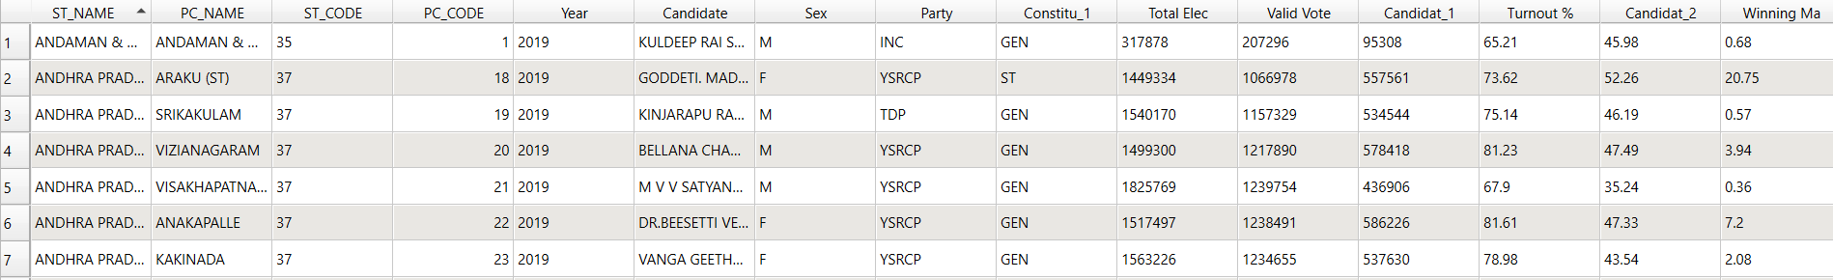

**Figure 1 : Attribute table for PC SHP file**

## 2.2 AC Shapefile

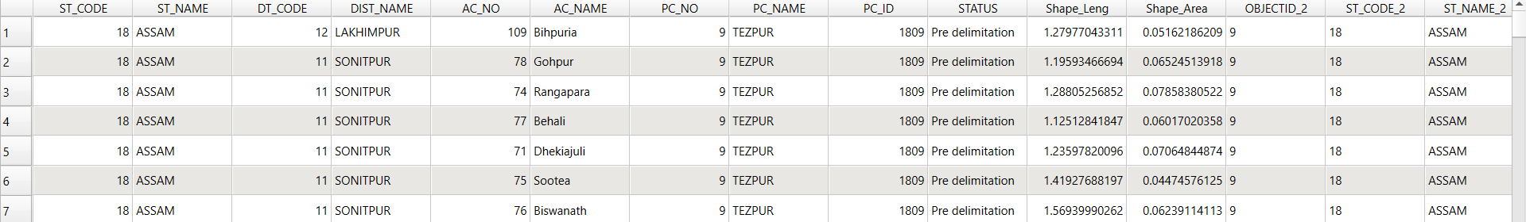

**Figure 2 : Attribute table for AC SHP file**

# Work Flow Chart

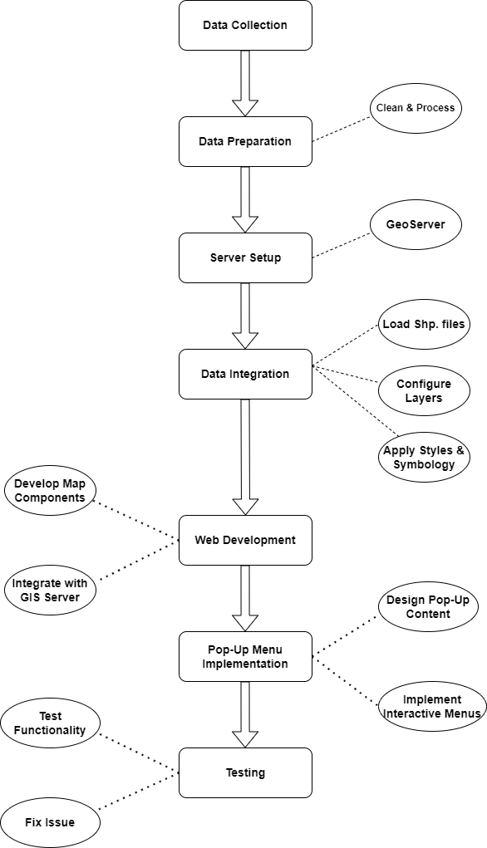

**Figure 3 : Workflow**

# Data Pre-Processing

1. **Adding Party Name and Reservation Column in PC/AC Shapefile**:  
   By using the join table method, integration of the party name and reservation type data into the PC/AC shapefile.
2. **Counting Booths**:  
   By utilizing the "Count Points in Polygon" tool, calculation of the number of points within each polygon and add this count to the attribute table.

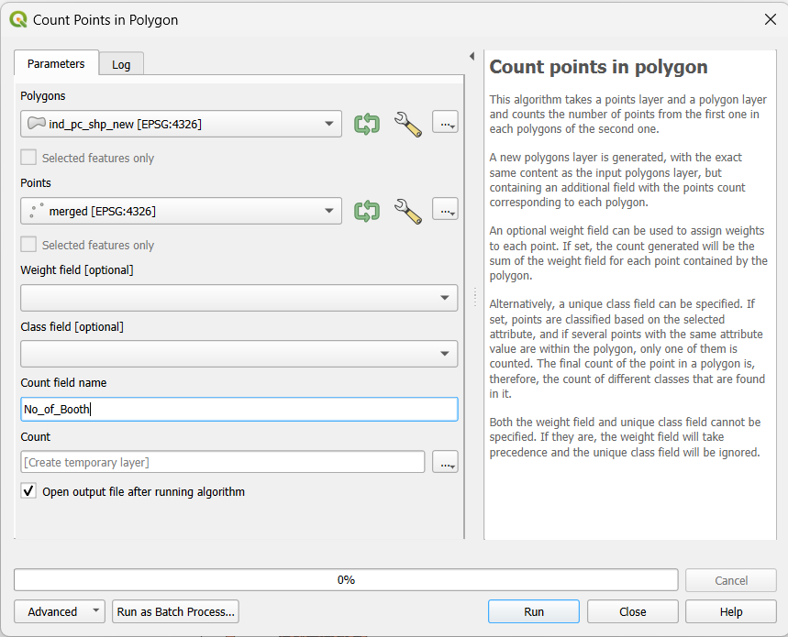

**Figure 4 : Counting Booths**

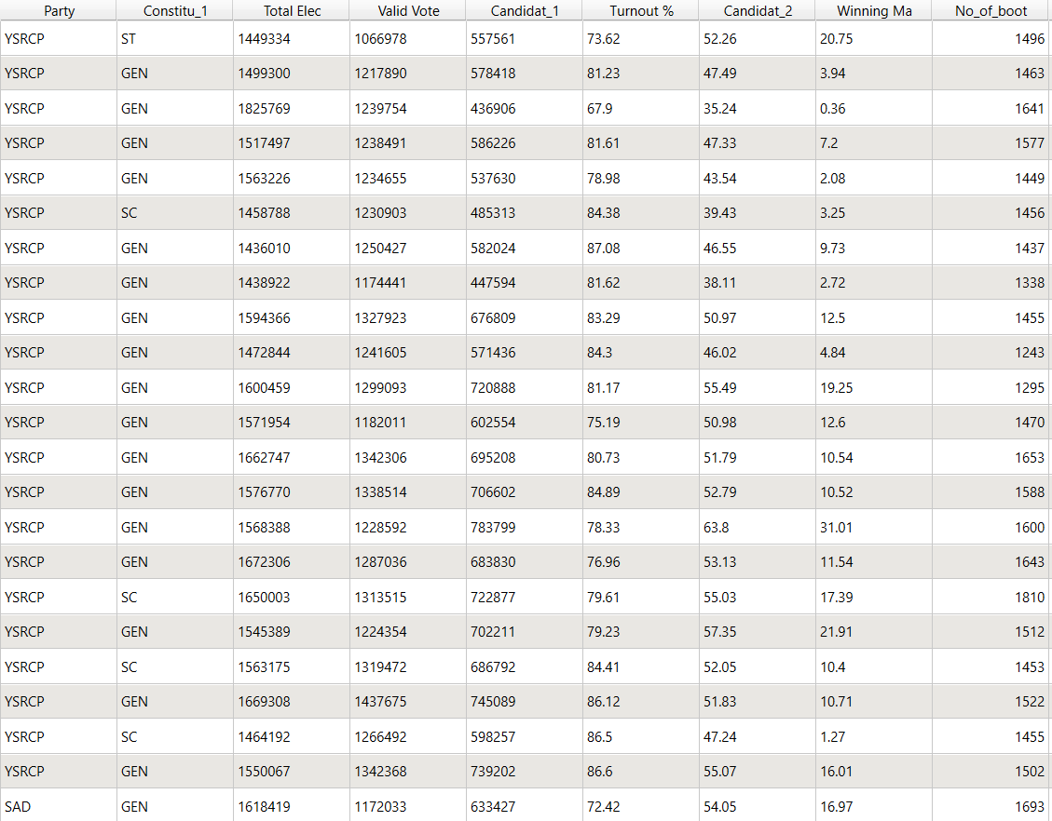

**Figure 5 : Attribute Table**

# Development Process

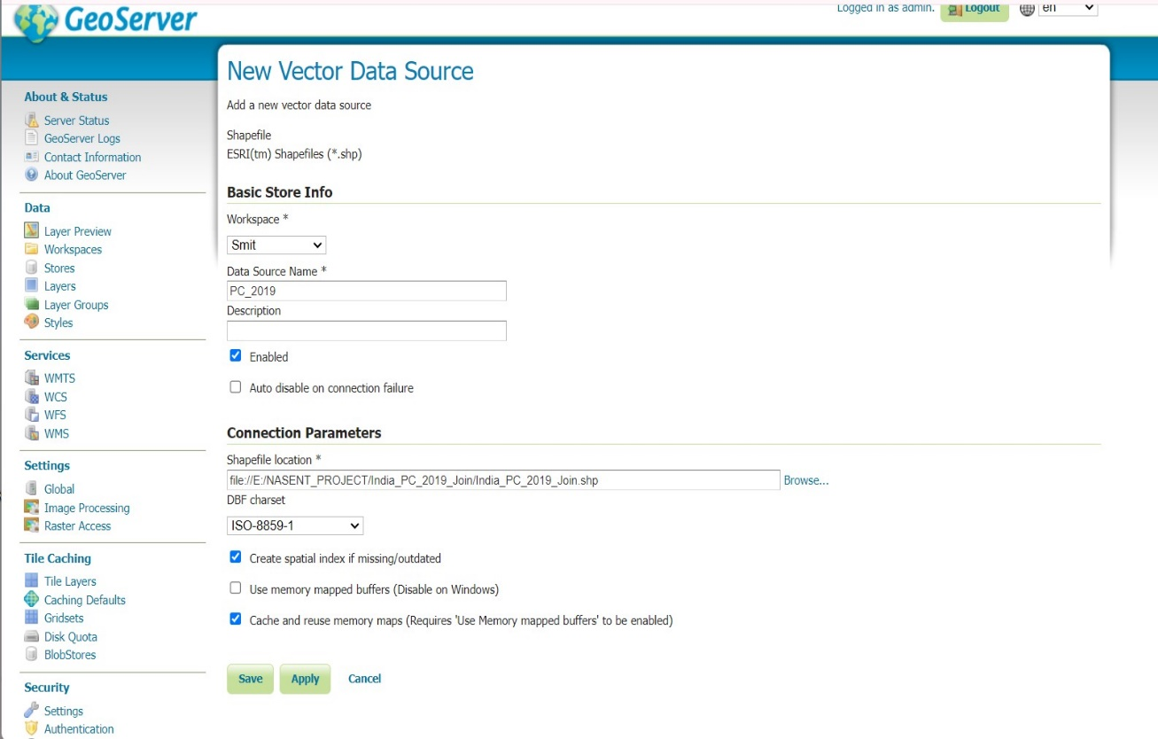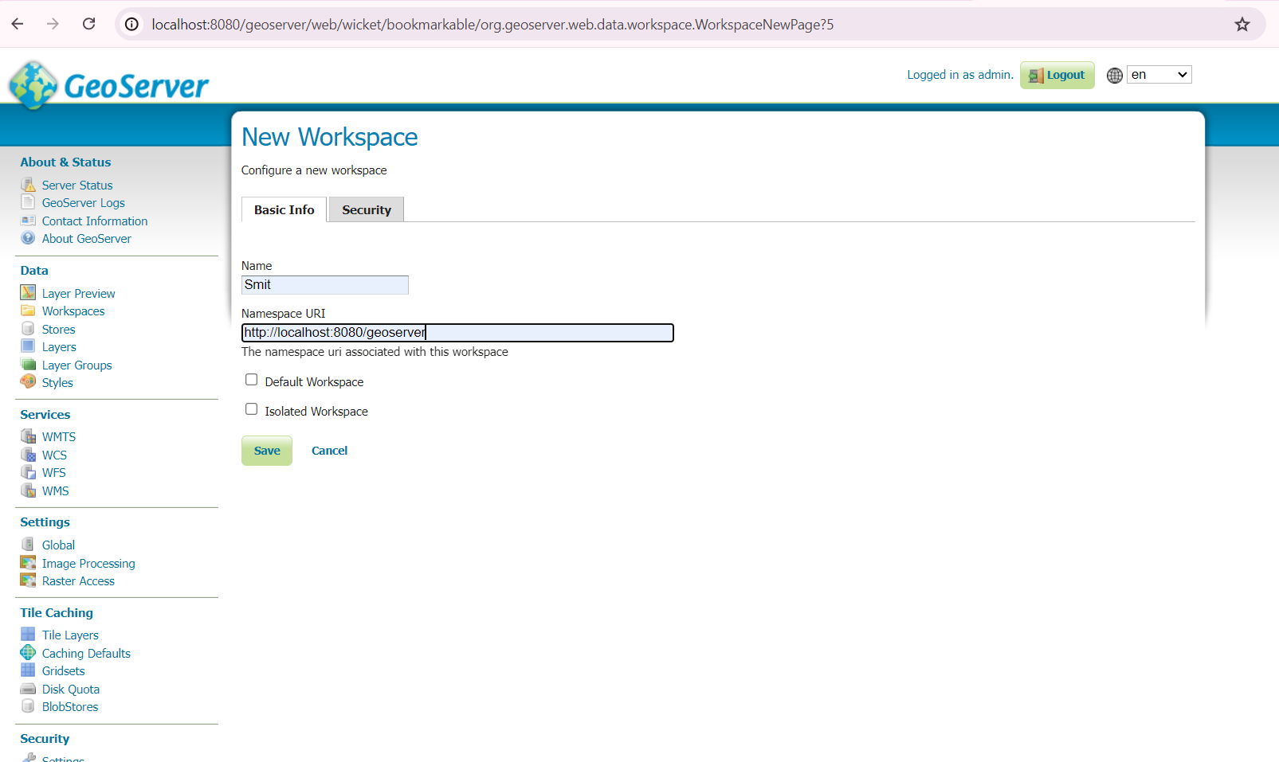

**Figure 6 : Create a Workspace**

**Figure 7 : Create a Store**

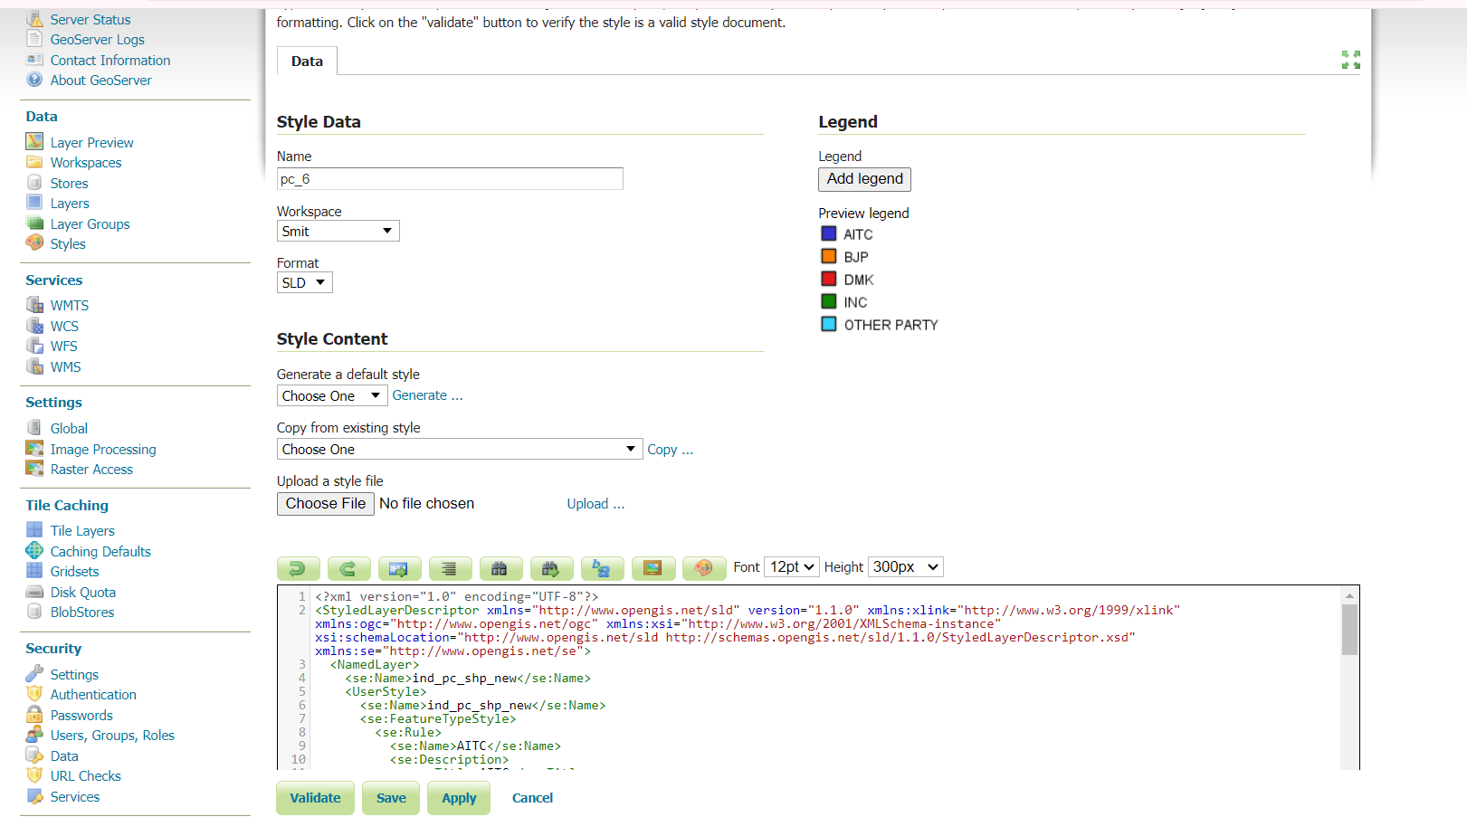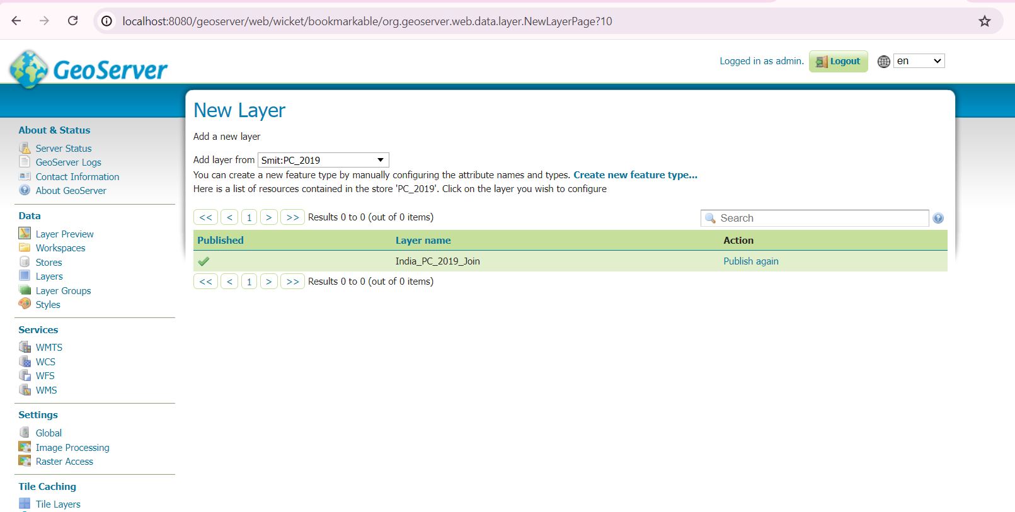

**Figure 8 : Publish Layer**

**Figure 9 : Create Style**

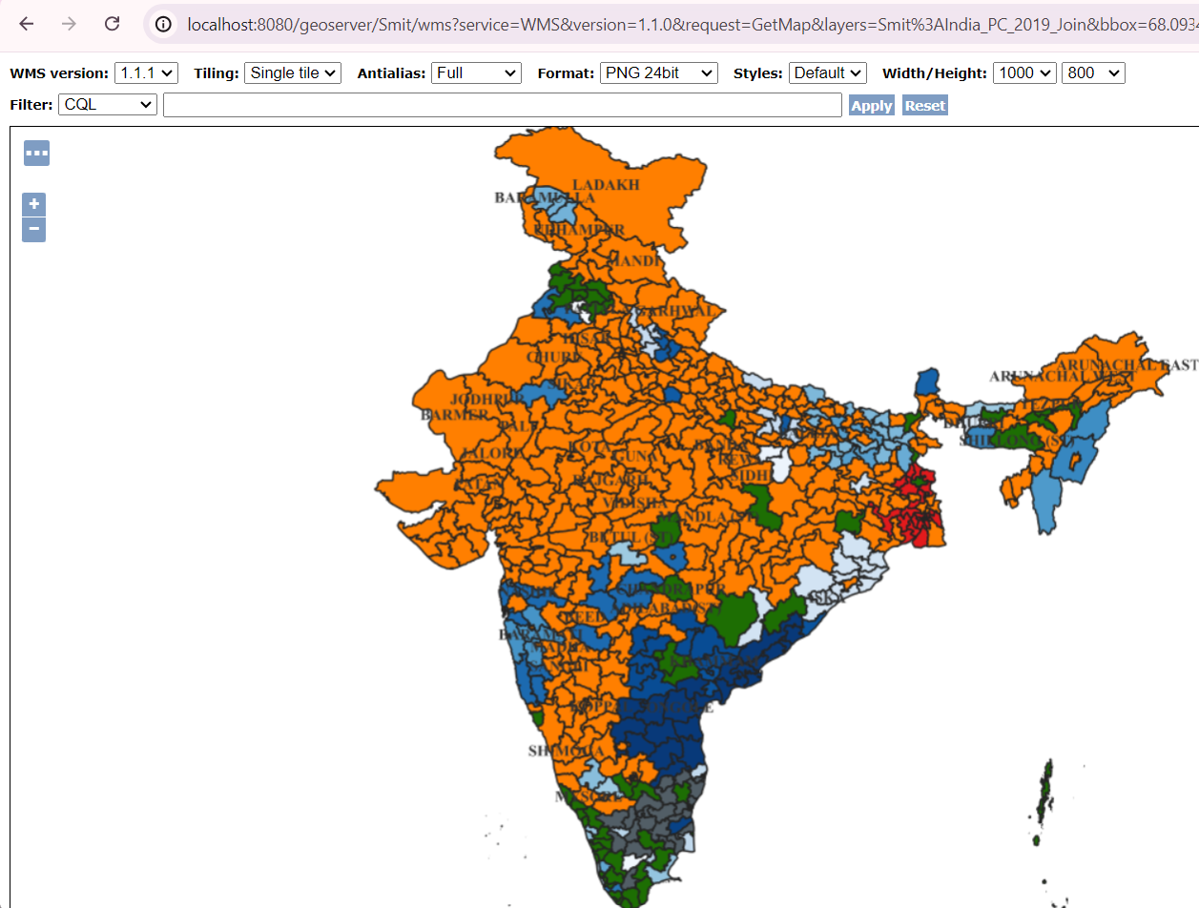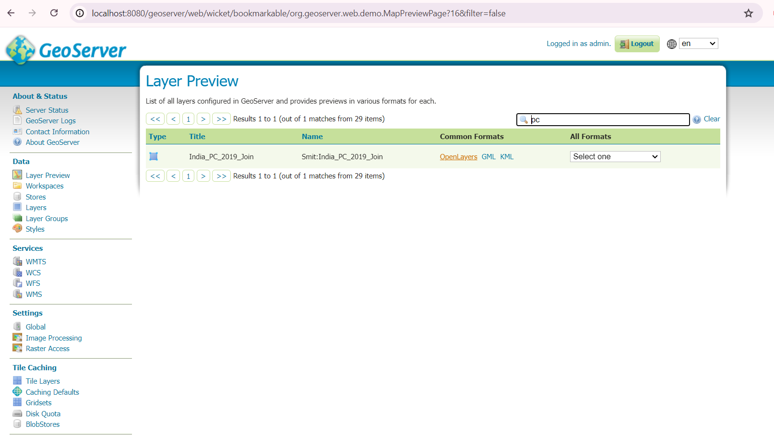

**Figure 11 : PC MAP**

**Figure 10 : Layer Preview**

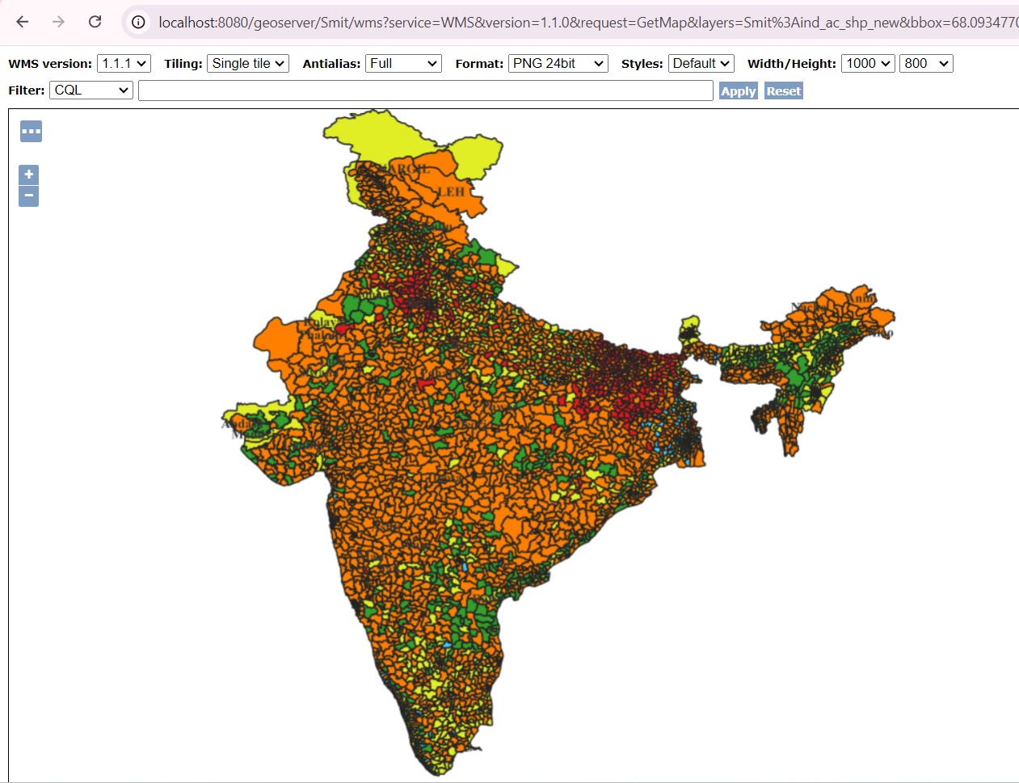

**Figure 12 : AC Map**

# RESULT

The web page features three main sections: Layer Selection, Layer Filtering, and Legend Information and on click get info.

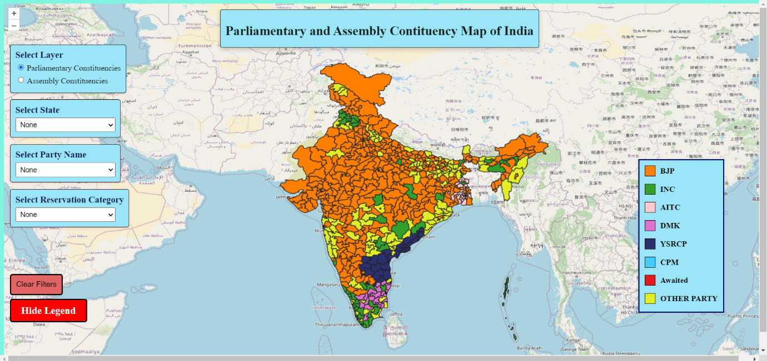Demo Link : <https://drive.google.com/drive/folders/1VTBUgX1tvPrL-HSNOnkf1_rC-OfAxccj?usp=drive_link>

**Figure 13: Web page for Constituency Map of India**

## 6.1 Layer Selection & Filtering

• **Select Layer**: Users begin by selecting from various data layers to display on the map, setting the stage for the map’s content based on the chosen layer. (Parliamentary Constituency and Assembly Constituency)

**Figure 14 : Parliamentary and Assembly Constituency Layer**

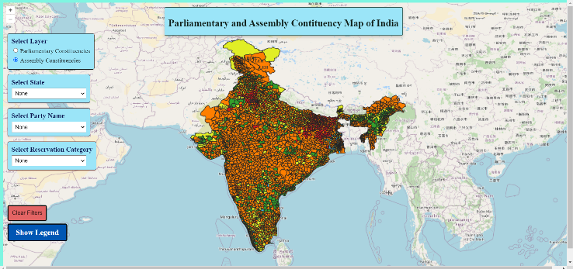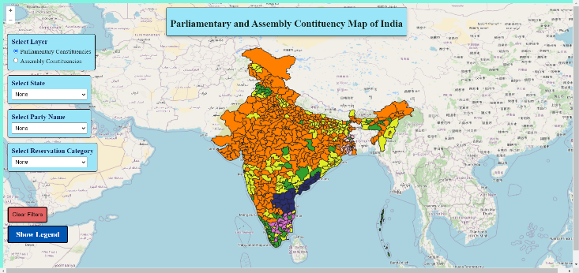

• **Select Filter** : After selecting a layer, users can specify particular attributes or features within that layer, such as selecting by State, Party Name, or Reservation Category.

**Figure 15 : Filter by state Name**

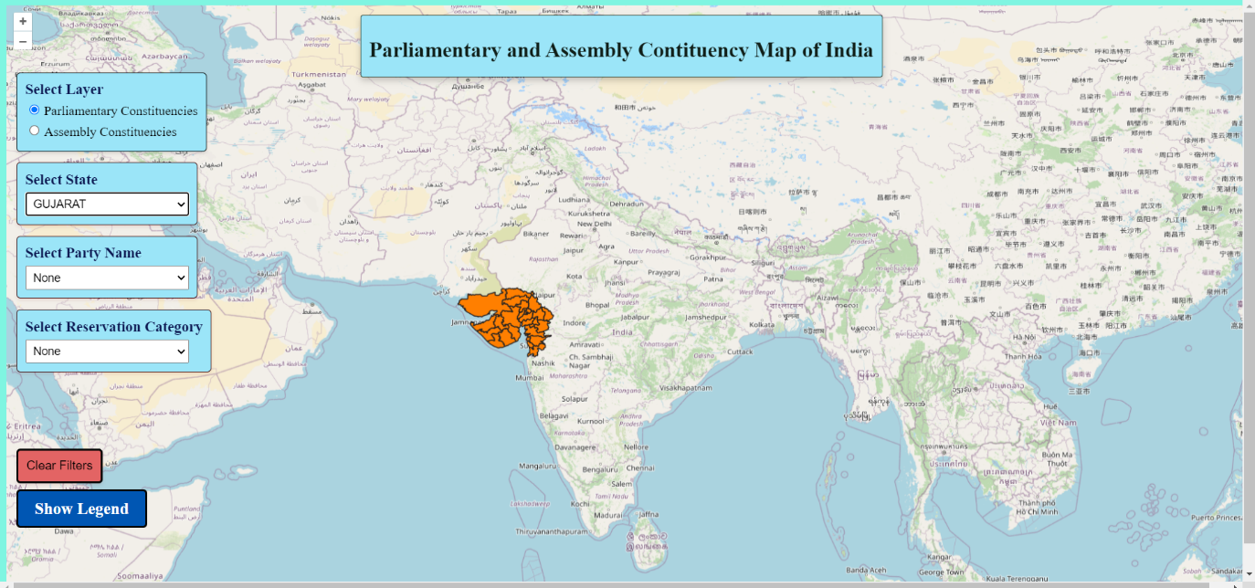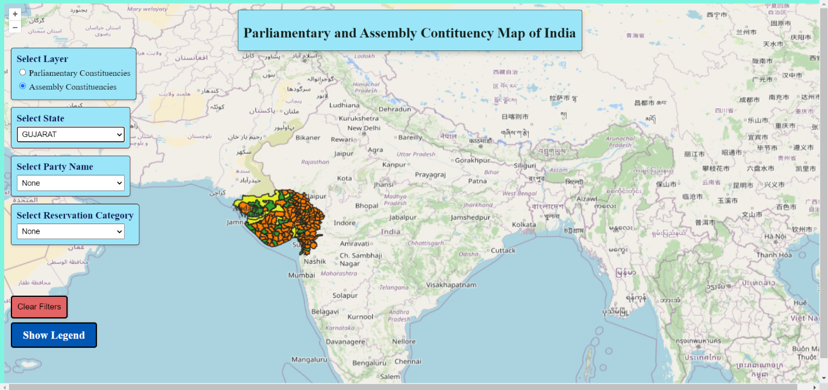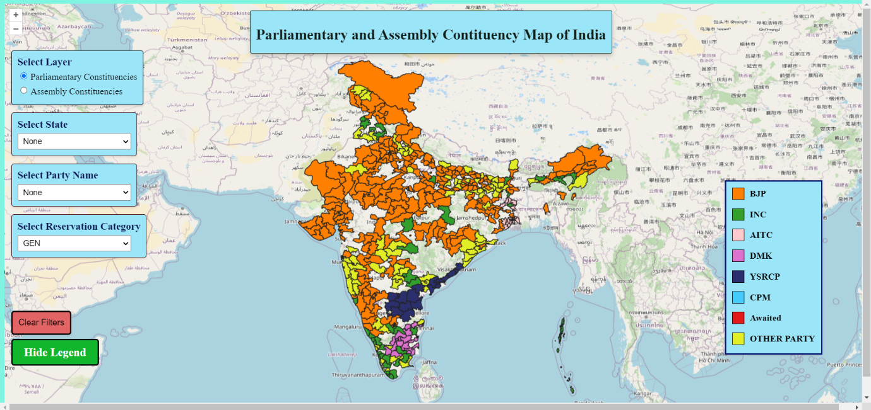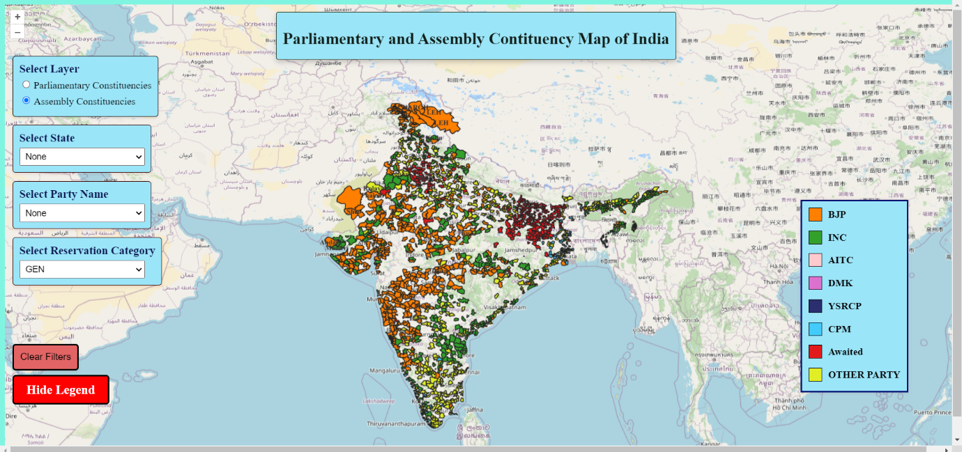

**Figure 16 : Filter by Party Name**

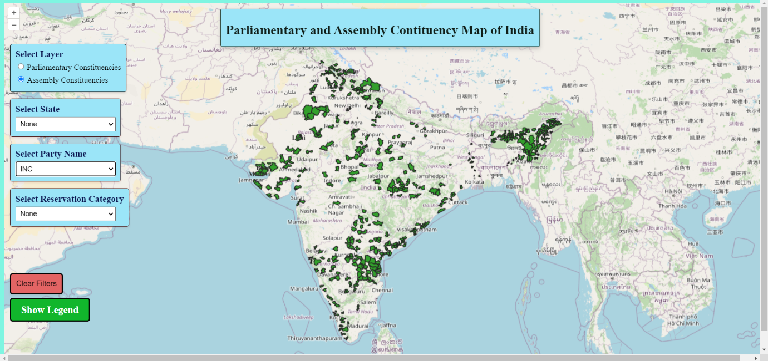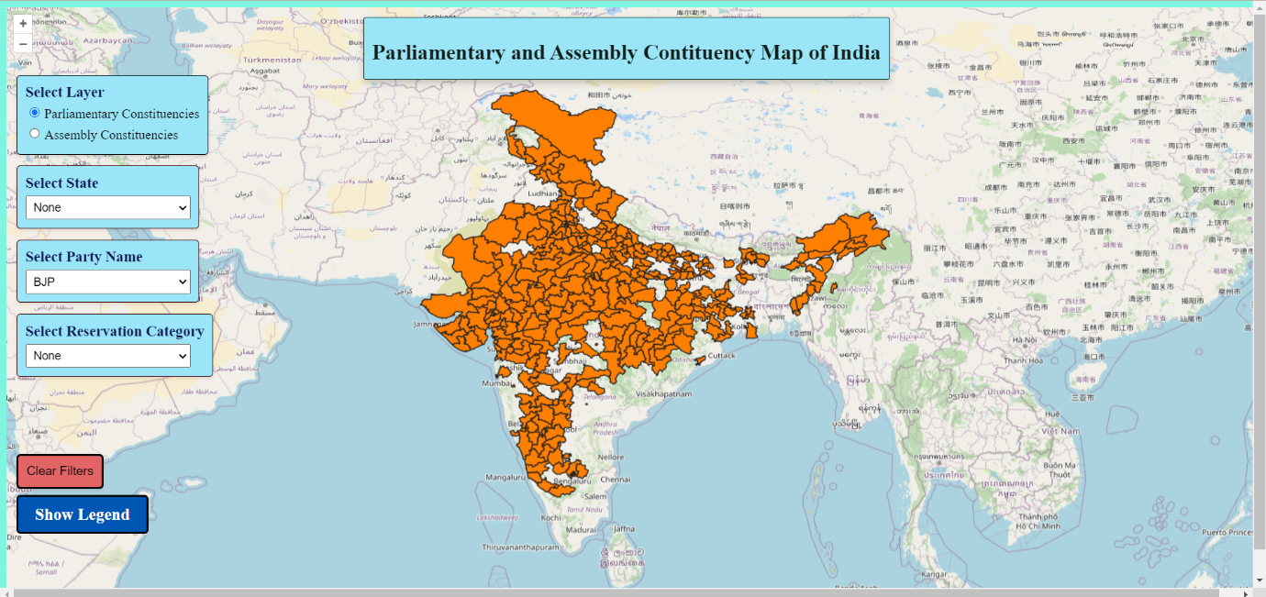

• **Apply Filter**: After Selecting filter, click apply button to get results.

• **Clear Filters**: Users can clear all filters using the clear button, returning the map to its default view without any filtering applied. This option allows users to start a new filtering process if desired.



**Figure 17 : Clear Filter**

## ****6.2**** Legend Display

The legend display function assists users in interpreting the map's symbols.

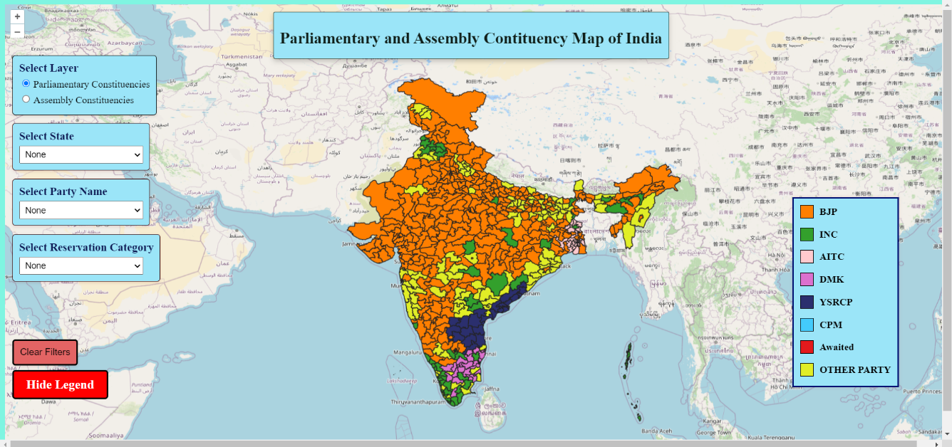**Toggle Legend Visibility:** Users can manage the legend's visibility with a button. When visible, the legend clarifies the meanings of different symbols, colors, or patterns on the map, which correspond to various data categories or values. Clicking the button again hides the legend, ensuring a clutter-free interface when it is not required.

**Figure 18 : Display Legend**

## 6.3 On click get info

• **Show Feature Details**: When a point is selected with the information retrieval function active, a popup appears displaying detailed information about the chosen feature. This functionality is essential for a thorough analysis and deeper insight into individual data points.

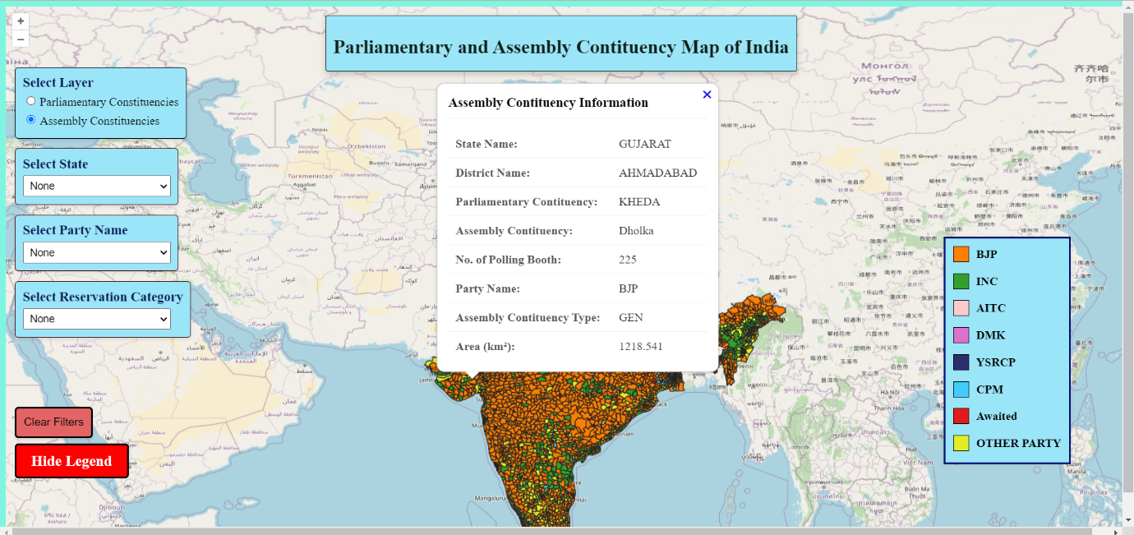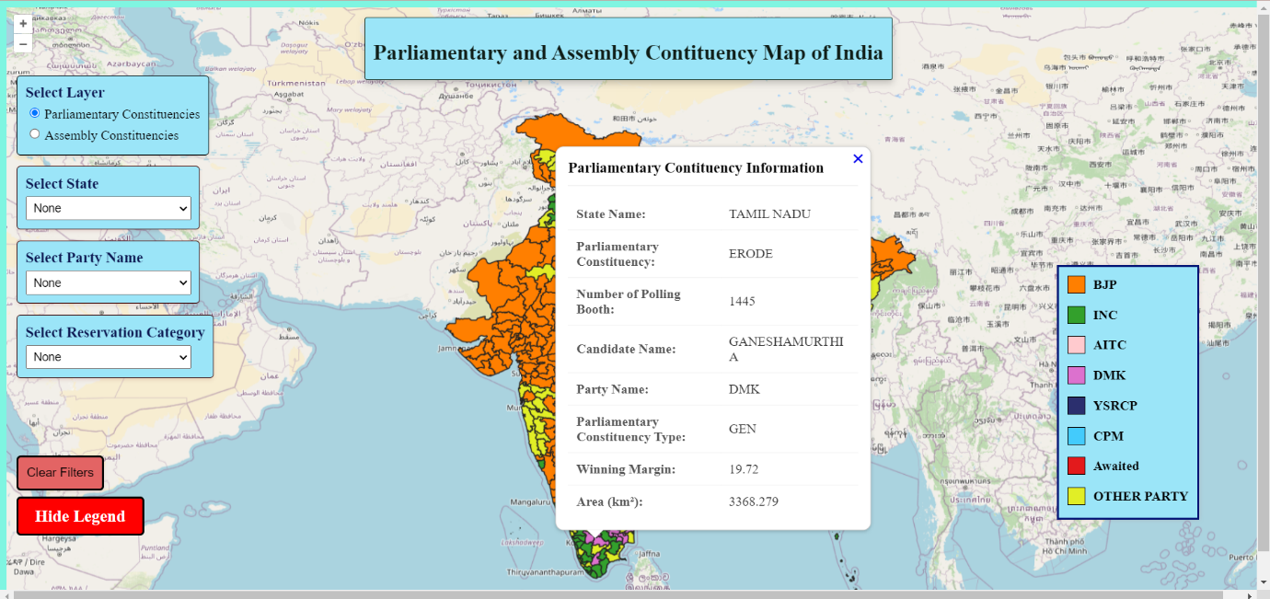

**Figure 19 : Feature information by Popup**

Top of Form

Bottom of Form

## 6.4 Conclusion

* The interactive map visualization tool is crafted to deliver a comprehensive suite of capabilities for geographic data analysis.
* With features such as layer selection, attribute filtering, map switching, legend control, and detailed feature information retrieval, the application offers a powerful platform for users to explore and interpret spatial data.
* The intuitive design and adaptable functionalities ensure that users can effectively manage and analyse their geographic information to meet their specific requirements.

­

# REFRENCES

1. **"Web GIS for Natural Resource Management"** by Hannes Taubenböck, Anja Wurm, Peter Esch, and Stefan Dech

This paper discusses the application of Web GIS in various domains, including natural resource management, which can provide insights into the technological aspects and implementation strategies applicable to our project. [[link]](https://pub.uni-bielefeld.de/record/2674065)

1. **"DEVELOPING A MAP USE MODEL FOR WEB MAPPING AND GIS "** by Bert Veenendaal

This paper outlines the development of interactive web mapping applications using OpenLayers, an open-source JavaScript library for displaying map data in web browsers. [[link]](https://www.researchgate.net/publication/280221416_Developing_a_map_use_model_for_web_mapping_and_GIS)